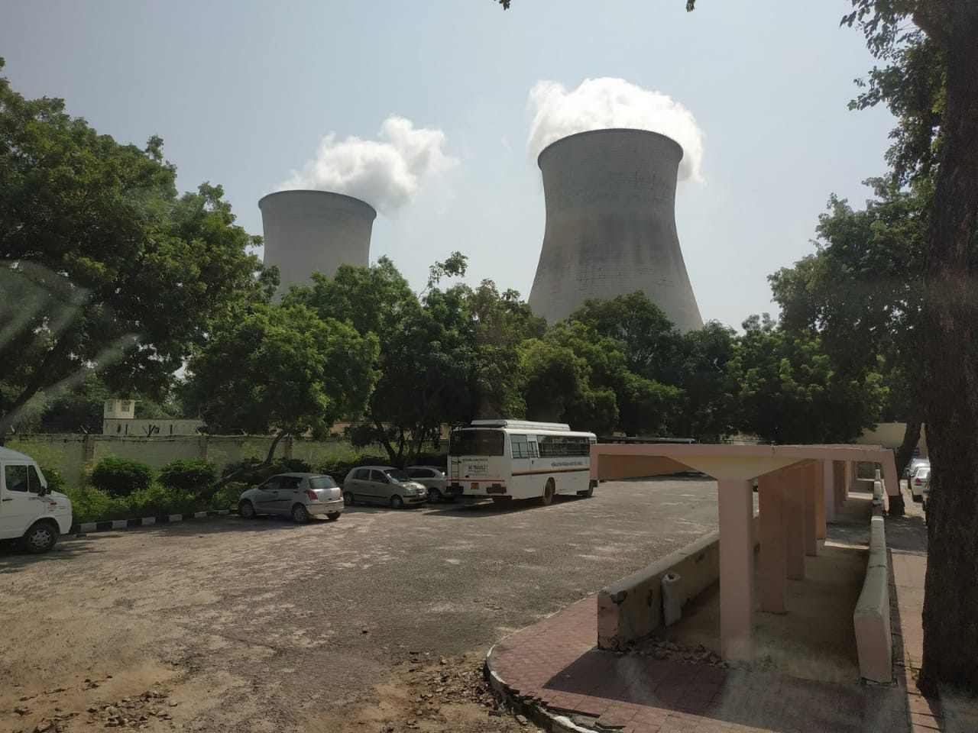  Figure 1: Narora Atomic Power Station / Source: Self  Narora Atomic Power Station  India’s first indigenous atomic power station | Report  This is a summary report of the field trip that the students attended on 15th September, 2018 to Narora Atomic Power Station.

Narora Atomic Power Station
Field Trip Report

Name:
ID:
Date of Visit: 15th September 2018 (Signature of Instructor)
Date of Submission:
Content
Content Page Number

- Introduction …3
- Nuclear Energy …5
- Major Virtues of Nuclear Energy …7
- Pressurized Heavy Water Reactors …7
- Nuclear Power in India …9
- Indian Atomic Programme …12
- Nuclear Waste Management …13
- Safety of NAPS …15
- Observation …17
- Conclusion …18
- References …19

Introduction

Narora Atomic Power Station

One of the chief aims of the Department of Atomic Energy is the development of nuclear energy for economic generation as an alternative source of electric power because it is well known that in due course of time the conventional sources of energy will be exhausted and then we will have to switch to unconventional sources of energy. At that time, atomic power will become an inevitable option for India.
Narora Atomic Power Station is one of the primary energy generating atomic stations in India and fourth in number to be constructed, first of which is the nuclear power station in Tarapur, Maharashtra. Narora is also one of India’s first fully indigenous atomic power stations.
Located on the banks of holy River Ganga, Narora is an ancient village and part of the Bulandshahr district in Western Uttar Pradesh. It is located at a distance of 68km from the district headquarters. The plant houses two reactors, each a pressurized heavy-water reactor (PHWR) capable of producing 220 MW of electricity. Commercial operation of the first reactor began on 1 January, 1991and of the second reactor on 1 July, 1992.
It is a unit of Nuclear Power Corporation of India which is a Public Sector Enterprise under the Department of Atomic Energy (DAE).


Figure 2: Narora Atomic Power Plant / Source: Self
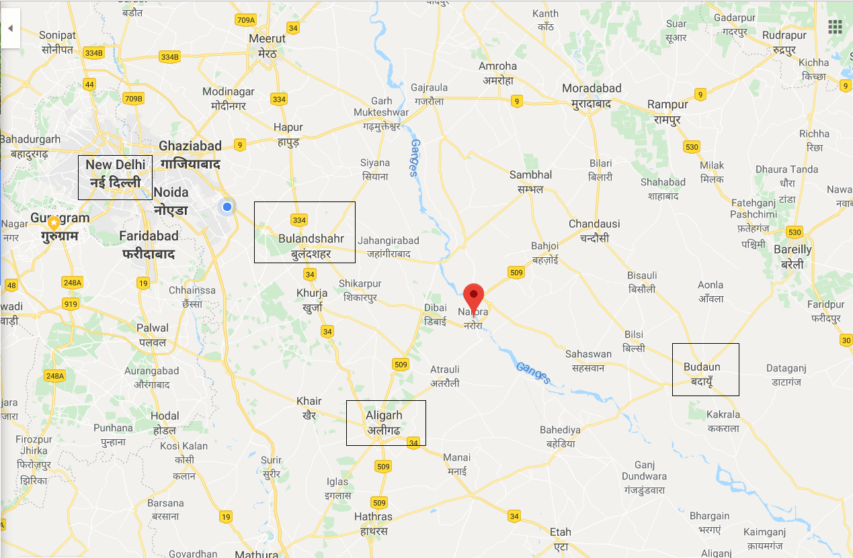
Figure 3: Map of Narora / Source: Google Maps

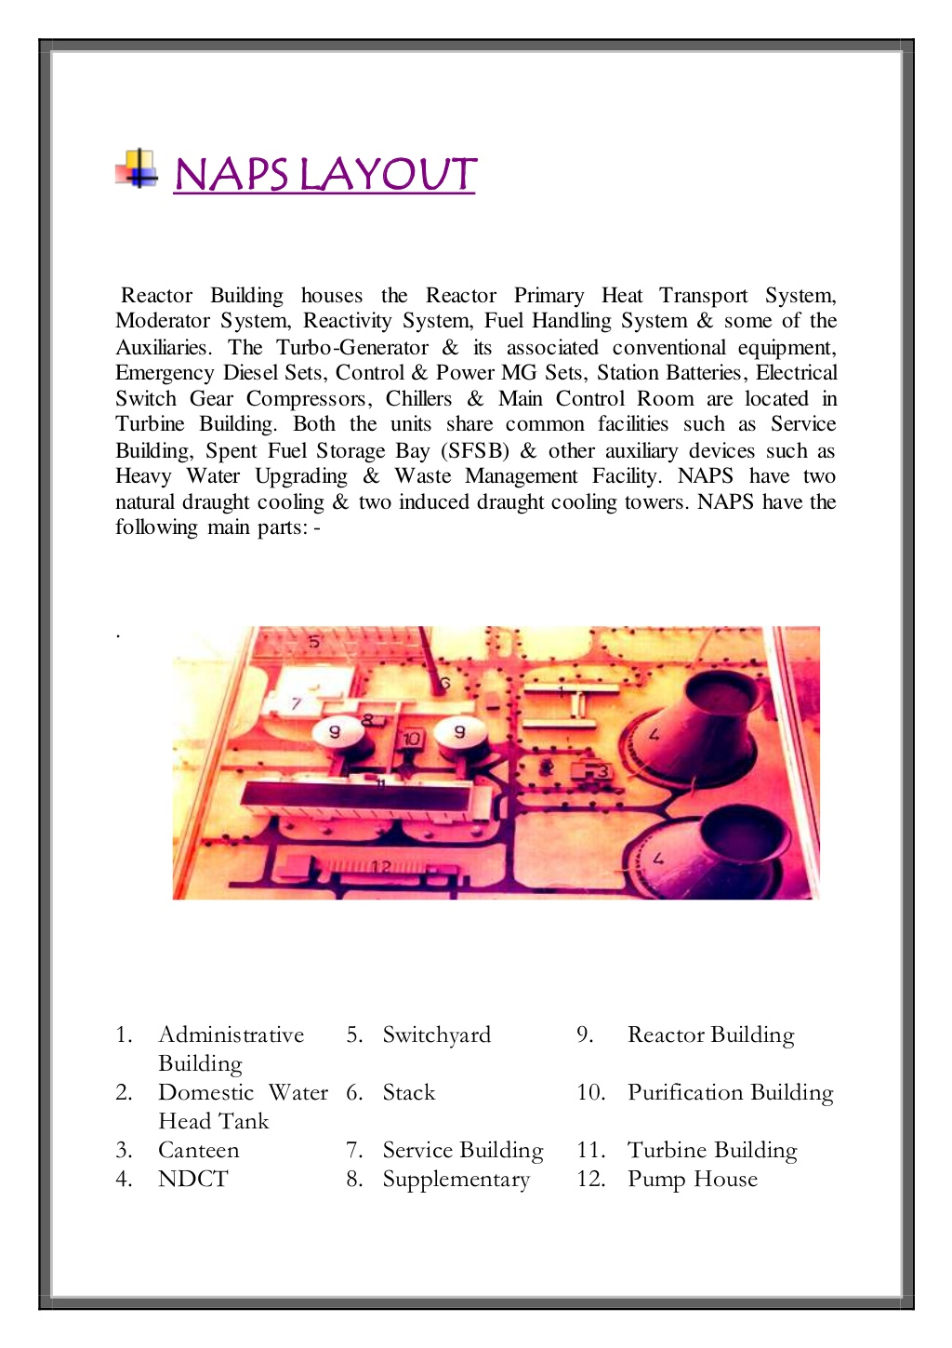
Figure 4: NAPS Layout / Source: NPCIL NPTEL

Nuclear Energy

Nuclear technology uses the energy released by splitting the atoms of certain elements. It was first developed in the 1940s, and during the Second World War research initially focused on producing bombs. In the 1950s attention turned to the peaceful use of nuclear fission, controlling it for power generation. Nuclear power plants are operational in 30 countries worldwide. In fact, through regional transmission grids, many more countries depend in part on nuclear-generated power; Italy and Denmark, for example, get almost 10% of their electricity from imported nuclear power. Around 11% of the world's electricity is generated by about 450 nuclear power reactors. About 60 more reactors are under construction, equivalent to 16% of existing capacity, while an additional 150-160 are planned, and equivalent to nearly half of existing capacity. In 2016 nuclear plants supplied 2477 TW of electricity, up from 2441 TW in 20151. This is the fourth consecutive year that global nuclear generation has risen, with output 130 TW higher than in 2012.

Graph 1: Region Wise Production of Nuclear Energy every year
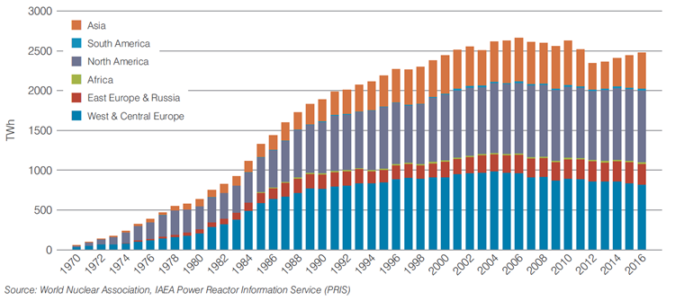
Source: World Nuclear Association, IAEA Power Reactor Info Service

Graph 2: World Electricity Production by Source (2017)
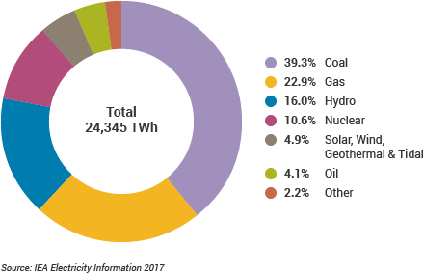

Sixteen countries depend on nuclear power for at least one-quarter of their electricity. France gets around three-quarters of its electricity from nuclear energy; Hungary, Slovakia and Ukraine get more than half from nuclear, whilst Belgium, Czech Republic, Finland, Sweden, Switzerland and Slovenia get one-third or more. South Korea and Bulgaria normally get more than 30% of their electricity from nuclear, while in the USA, UK, Spain, Romania and Russia about one-fifth of electricity is from nuclear. Japan is used to relying on nuclear power for more than one-quarter of its electricity and is expected to return to somewhere near that level.
Figure 5: Nuclear Energy Generation by country (2016)
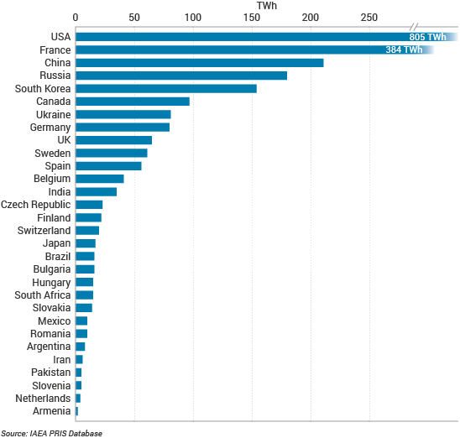

Major Virtues of Nuclear Power
- Nuclear power is environmentally benign, and is clean source of base load electricity, available 24x7. As per World Nuclear Association ( WNA ) report, life cycle mean Green House Gas ( GHG ) emissions from nuclear is about 28 tonnes/ MU which is about the same as that from wind/hydro/solar.
- Nuclear power is safe and reliable source of energy. Safety is overriding priority in all activities. To achieve highest safety, nuclear plants are designed and operated using a ‘defence-in-depth’ approach with multiple safety systems. Every activity in a nuclear is reviewed and lessons are learnt and the systems and procedures are further secured and improved
- Nuclear power is a source of continuous, reliable, large scale, round the clock electricity. It is not subject to changing weather or climate conditions. Nuclear Power Plants maintain high availability factors. In India, various operating units have recorded continuous operation of more than a year for 24 times as on August 31, 2017.
- Nuclear power is cost competitive with other forms of electricity generation. Also, in case of nuclear power, decommissioning and waste management costs are internalised in tariff, whereas in case of fossil fuel base power plants, impact of CO2 emission is not internalised in the tariff. NPCIL’s average tariff of nuclear power generation in the last three years has been in range of Rs. 2.78/KWh to Rs. 2.95/KWh which is competitive in the current power scenario in the country.
- Nuclear Power has a huge potential and can ensure long term energy security of the country in a sustainable manner by utilizing the vast indigenous thorium resources for large scale of electricity generation for centuries.

Pressurized Heavy Water Reactors

A pressurized heavy-water reactor (PHWR) is a nuclear reactor that generates energy using the natural uranium-235 as its fuel, which uses heavy water (deuterium oxide D2O) both as its coolant and moderator. The heavy water coolant is kept under pressure, allowing it to be heated to higher temperatures without boiling, much as in a pressurized water reactor. The use of heavy water as moderator facilitates the use of natural uranium as the fuel. The cycle diagram of coolant in PHWR is similar to that in a PWR with the difference being the use of heavy water as primary coolant. A schematic diagram of working of a PHWR plant is shown in Figure 1.

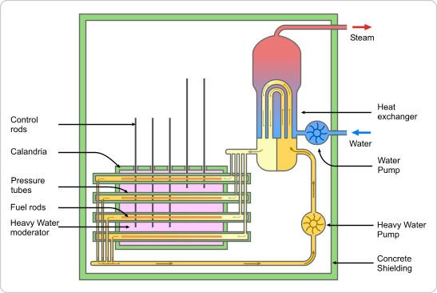
Figure 6: A schematic diagram of PHWR / Source: nuclearstreet.com
Composition of a Pressurized Heavy Water Reactor

PHWR Core CANDU (Canada Deuterium Uranium) type reactors are the common form of PHWR. The core component pellets are stacked in the form of rods. These rods are arranged in concentric circles of 37 fuel rods. A number of such fuel assemblies are inserted into pressure tubes of calandria.
Calandria is a low-pressure horizontal vessel, consisting of circular channels arranged in a regular fashion and immersed in moderator (heavy water). The pressure tubes are loaded in the channels of calandria with the coolant (heavy water inside the pressure tubes. This extracts the heat released during fission and transfers the same to the secondary coolant (light water) that boils to generate steam. The Indian PHWR consists of a calandria that contains heavy water (moderator) at near ambient pressure and temperature.
Each pressure tube contains 12 fuel bundles. Each fuel bundle has 19 fuel rods and is 495 mm long weighing about 16 kg. A schematic diagram of arrangement of fuel pellets form fuel bundle, their loading inside pressure tubes and the placement of pressure tubes in calandria are shown in Figure2.

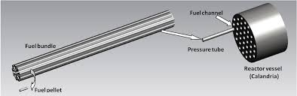
Figure 7: Arrangement of fuel pellets in fuel bundles / Source: Google Images
Heavy Water is used as a coolant and a moderator in Pressurized Heavy Water Reactors. The key to maintaining a nuclear reaction within a nuclear reactor is to use the neutrons released during fission to stimulate fission in other nuclei. With careful control over the geometry and reaction rates, this can lead to a self-sustaining chain reaction, a state known as ‘critical reaction’. To achieve critical reaction we need to slow down the fast moving electrons by absorbing their kinetic energy. This is achieved by using a moderator. At the same time, heavy water is used as a coolant to regulate the temperature of the reaction and generate steam. The heavy water which Narora acquires is made indigenous which is worth 20,000 per kg.
Control rods are used in nuclear reactors to control the fission rate of uranium and plutonium. They are composed of chemical elements such as boron, silver, indium and cadmium that are capable of absorbing many neutrons without themselves fissioning.
Poison Addition Shutdown system is a shutdown mechanism installed in nuclear reactors in case of a rapid reaction. Rapid shutdown is carried out when the reactor operates under circumstances that are dangerous to personnel and plant equipment. It is also called ‘reactor tripping’. Shutdown system is designed to shut down the reactor safely from any operational condition and maintain in the safe shutdown condition. The system is also responsible for ensuring safety of the reactor after postulated accident conditions. Hence, the shutdown system is designed to ensure safe shutdown from normal operating condition as well as from accident conditions. A typical 220 MW PHWR contains three shutdown systems:
- Primary Shutdown System (PSS)
- Secondary Shutdown System (SSS)
- Automatic Liquid Poison Addition System (ALPAS) - During the long shutdown, positive reactivity may be added to the system due to decay of xenon. This positive reactivity addition to the system may exceed the worth (ability to inject negative reactivity) of either primary or secondary systems. Under these circumstances, to maintain the reactor sub-critical under shut down state, there must be additional sources of negative reactivity. This is done by Automatic Liquid Poison Addition System (ALPAS) whose functions are:
(a) To ensure maintenance of subcritical conditions by automatic addition of poisons to moderator as and when necessary.
(b) To facilitate manual addition of liquid poison to moderator at predetermined quantities.
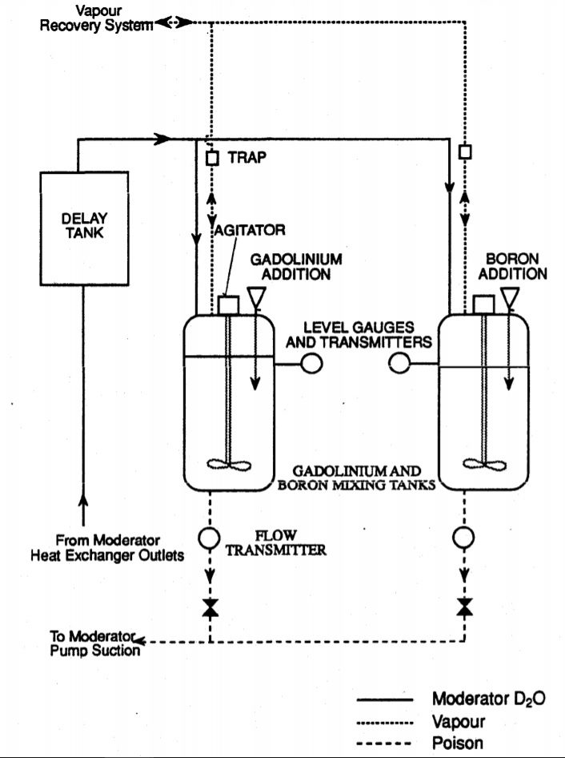
Figure 8: Typical Moderator Liquid Polson Addition System / Source: Candu.org

Nuclear Power in India
After India attained independence, in 1947, the Atomic Energy Commission was set up in 1948 for framing policies in respect of development of atomic energy in the country. The Department of Atomic Energy was established in 1954 with Dr. Bhabha as Secretary to implement the policies framed by the Atomic Energy Commission. Sir J.R.D Tata was one of the longest serving members in the Atomic Energy Commission and played a significant role in shaping the policies related to atomic energy program in the country.
In India, nuclear energy development began with the objectives of peaceful uses of atomic energy in improving the quality of life of the people and to achieve self-reliance in meeting the energy needs. The commercial Nuclear Power program, started in 1969 with the operation of TAPS 1&2 (BWR Thus playing a complementary role in meeting the country’s energy demand. However, in long term, it is expected to play a significant role in meeting the huge electricity demand of the country.
Nuclear power is the fifth-largest source of electricity in India after coal, gas, hydroelectricity and wind power. As of March 2018, India has 22 nuclear reactors in operation in 7 nuclear power plants, having a total installed capacity of 6,780 MW. Nuclear power produced a total of 35 TW and supplied 1.96 per cent of Indian electricity in 2017. 6 more reactors are under construction with a combined generation capacity of 4,300 MW.

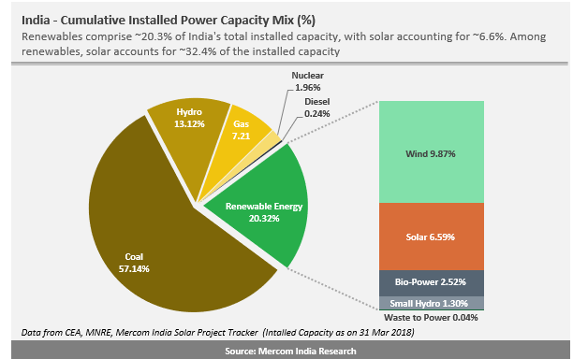

India is home to 7 active nuclear power plants generating a total of 6780MW of energy. We also have 13 reactors which have been planned are under construction, including two 1000MW reactors in Tamil Nadu.
The Kaiga Nuclear power plant is about to set a world record of running for more than 874 days consecutively and currently it is at 852 days.
Figure 9: Nuclear Power Plants in India
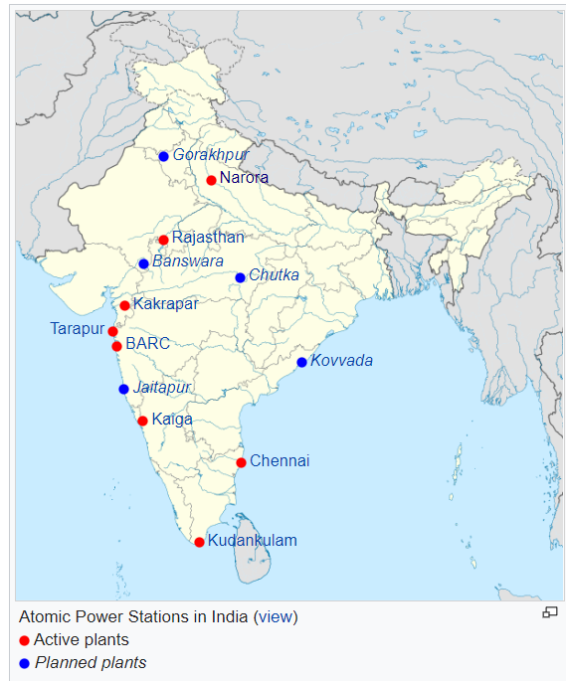

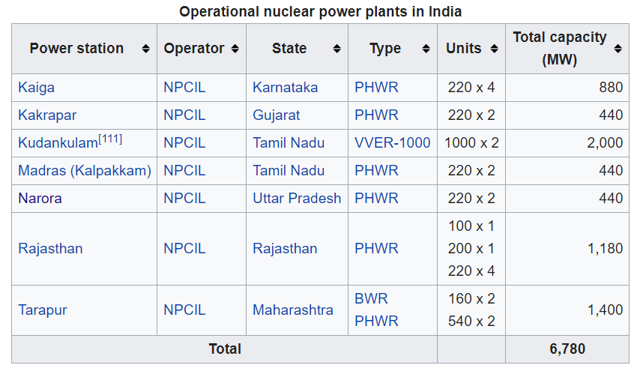
Source: NPCIL Estimation
India’s Atomic Program

India's three-stage nuclear power programme was formulated by Homi Bhabha in the 1950s to secure the country’s long term energy independence, through the use of uranium and thorium reserves found in the monazite sands of coastal regions of South India. The ultimate focus of the programme is on enabling the thorium reserves of India to be utilised in meeting the country's energy requirements.
The country published about twice the number of papers on thorium as its nearest competitors, during each of the years from 2002 to 2006. The Indian nuclear establishment estimates that the country could produce 500 GW for at least four centuries using just the country’s economically extractable thorium reserves.
As of August 2014, India's first Prototype Fast Breeder Reactor had been delayed - with first criticality expected in 2015 - and India continued to import thousands of tonnes of uranium from Russia, Kazakhstan, France, and Uzbekistan. The 2005 Indo-US Nuclear Deal and the NSG waiver, which ended more than three decades of international isolation of the Indian civil nuclear programme, have created many hitherto unexplored alternatives for the success of the three-stage nuclear power programme.
Homi Jehangir Bhabha, the founding Chairman of India's Atomic Energy Commission and the architect of Indian three-stage (thorium) programme. Homi Bhabha conceived of the three-stage nuclear programme as a way to develop nuclear energy by working around India's limited uranium resources. Thorium itself is not a fissile material, and thus cannot undergo fission to produce energy. Instead, it must be transmuted to uranium-233 in a reactor fuelled by other fissile materials. The first two stages, natural uranium-fuelled heavy water reactors and plutonium-fuelled fast breeder reactors, are intended to generate sufficient fissile material from India's limited uranium resources, so that all its vast thorium reserves can be fully utilised in the third stage of thermal breeder reactors.

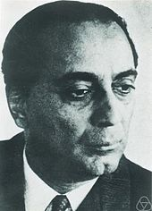
Figure 10: Homi Bhabha - Father of Indian Atomic Programme / Source: Google Images

The environmental impact of nuclear power results from the nuclear fuel cycle, operation, and the effects of nuclear accidents.
The greenhouse gas emissions from nuclear fission power are much smaller than those associated with coal, oil and gas, and the routine health risks are much smaller than those associated with coal. However, there is a "catastrophic risk" potential if containment fails, which in nuclear reactors can be brought about by overheated fuels melting and releasing large quantities of fission products into the environment. This potential risk could wipe out the benefits. The most long-lived radioactive wastes, including spent nuclear fuel, must be contained and isolated from the environment for a long period of time. On the other side, spent nuclear fuel could be reused, yielding even more energy, and reducing the amount of waste to be contained. The public has been made sensitive to these risks and there has been considerable public opposition to nuclear power.
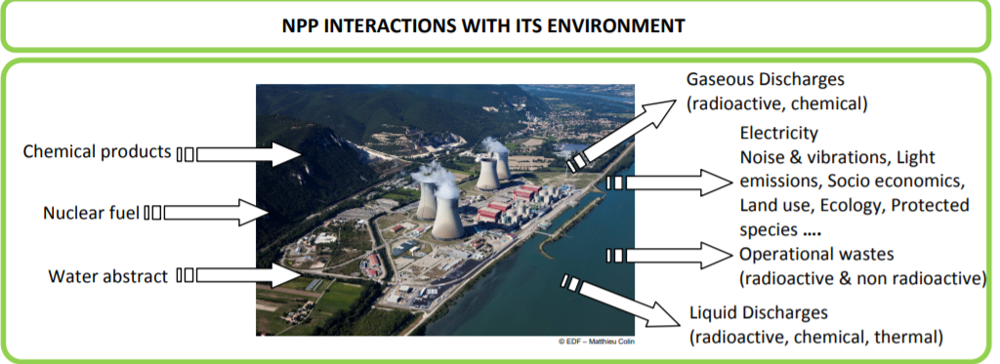
Figure 11: Environmental Effects of Nuclear Power Plants / Source: sfen.org

Nuclear Waste Management

Any activity related to the nuclear fuel cycle, that produces or uses radioactive materials generates radioactive waste. The management of radiation emitting radioactive material is a matter of concern and is what sets nuclear wastes apart.
Public acceptance of nuclear energy largely depends on the public assurance for safe management of radioactive wastes. Not all nuclear wastes are particularly hazardous or hard to manage as compared to other toxic industrial wastes.
Radioactive wastes are generated during various operations of the nuclear fuel cycle. Mining, nuclear power generation, and various processes in industry, defence, medicine and scientific research produce by-products that include radioactive wastes.
Radioactive waste can be in gas, liquid or solid form, and its level of radioactivity can vary. The waste can remain radioactive for a few hours or several months or even hundreds of thousands of years. Depending on the level and nature of radioactivity, radioactive wastes can be classified as exempt waste, Low & Intermediate level waste and High Level Waste.

India adopts closed fuel cycle policy. Spent fuel is not waste but resource for obtaining fuel for next stage by reprocessing. Spent fuel is reprocessed for the extraction of plutonium, uranium and other useful isotopes. Very small quantity of High level waste is generated during reprocessing. This waste is immobilized by vitrification in glass matrix, encapsulated in stainless steel double walled canisters and stored under surveillance in specially designed vaults. Ultimately, the waste is slated to be disposed off in deep underground geological repository with protective barriers.
During the process of generation of electricity, small quantities of low- and intermediate-level solid wastes are produced in nuclear power stations. After treatment, these wastes are concentrated and immobilized and stored under surveillance within the plant premises in earthen trenches, reinforced cement concrete trenches or tile-holes. Gaseous wastes comprising ventilation exhaust are filtered, monitored and disposed of through a 100-m-tall stack. Liquid wastes are treated, concentrated and immobilized in inert matrices and stored in special facilities under surveillance. The low level liquid waste is discharged after filtration treatment and dilution under monitoring. The radioactivity levels of gaseous and liquid wastes disposed off are very low compared to the permissible stipulated limit specified by AERB.
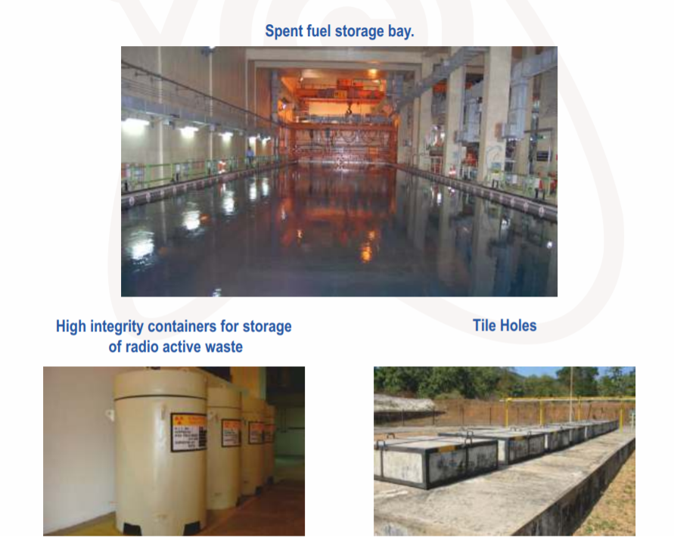
Figure9: Provisions for Nuclear Waste Management / Source: NPCIL Corporate Profile

Effective management involves segregation, characterization, handling, treatment, conditioning and monitoring prior to final disposal.
Proper disposal is essential to ensure protection of the health and safety of the public and quality of the environment including air, soil, and water supplies.

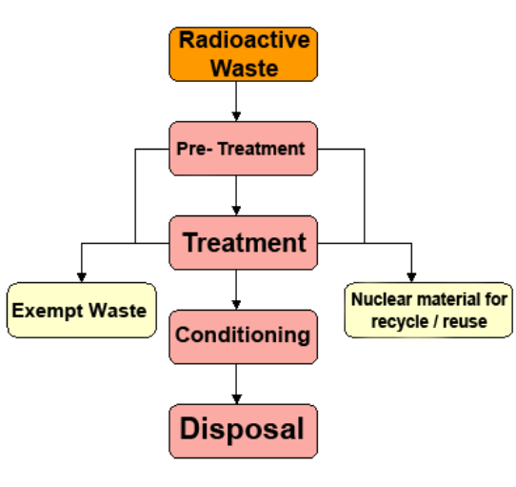
Figure 12: Process of treating radioactive wastes / Source: BARC

Radioactive waste disposal practices have changed substantially over the last twenty years. Evolving environmental protection considerations have provided the impetus to improve disposal technologies, and, in some cases, clean up facilities that are no longer in use. Designs for new disposal facilities and disposal methods must meet environmental protection and pollution prevention standards that are stricter than were foreseen at the beginning of the atomic age.
Disposal of radioactive waste is a complex issue, not only because of the nature of the waste, but also because of the stringent regulatory structure for dealing with radioactive waste. India has achieved self-reliance in the management of all type of radioactive waste. Decades of safe and successful operation of our waste management facility stand testimony to international standards. An ongoing effort to upgrade technology to minimize radioactive discharge is also on

Safety of NAPS

Safety is given paramount importance in design, construction and operation of nuclear power stations. To achieve highest safety, a defence in-depth philosophy is followed, involving multiple barriers, diversity, redundancy, independence and fail-safe design of the safety-related systems. Safety of nuclear power stations is further ensured through sound design, using international standards and codes, stringent quality assurance, approved operating procedures, in-service inspection and maintenance of safety systems, etc. Nuclear Power Plants are operated strictly in accordance to approved technical specifications and procedures by trained and licensed persons. Robust regulatory mechanism comprising multitier reviews are in place. There are also periodic audits and reviews at station, corporate and regulatory level.
Apart from that, Narora is surrounded by lush green forests and grassland cover which goes on to prove that the effect of radioactivity has been bare minimum in the vicinity of the Narora Atomic Power Station. Testimonials of people have shown that the effect of radioactivity has not at all affected their lives. Instead, they have been living healthy lives and have been bearing children who are healthy and strong. The people live normal lives free from the radiation and so on.
Environmental Monitoring & Studies
At each of NPP sites, Environmental Survey Laboratories (ESL) are set up, which are operated by an independent organization viz. Health Physics Division of Bhabha Atomic Research Centre, Mumbai. At the existing NPPs sites, ESLs have been collecting and analysing radioactivity levels in the samples of various environmental matrices in the radius of 30 km from the plant site. Their reports conclude that the dose to population at the fence resulting from the existing NPPs in the country is about 1.5% of the authorized dose limit of AERB, which is a small fraction of the natural background radiation. The doses at further distances are still lower.

At NPP sites, environmental studies such as condenser cooling water discharge studies, thermal ecological studies, biodiversity conservation studies etc. are carried out for insuring compliance to environmental standards and environmental clearance stipulations from regulating agencies such as MoEF, AERB and State Pollution Control Board. These studies have demonstrated that the effect of thermal discharges from NPPs on marine ecology is confined to a small area and is reversible in nature.

Observation
The dawn of the day, The 15rd September, 2018 marked a glorious start with a group of 48 vibrant students from all branches accompanied by two faculty members Mr. Mohd. Ahmed and Dr. Tripathi of the college. All the faces were filled with aspirations and zeal as they were about to acquire an unprecedented experience by venturing into something that they would not get an opportunity to do otherwise. The trip began at 7:30AM and we reached there by 10:30AM. After de-boarding the bus, students went through a rigorous check by the CISF personnel where they were asked to leave their phones behind. Students were taken to a stack block by a bus. A guest lecture was delivered by Mr. Mukesh Sharma, Scientific Officer, NAPS. He enlightened the audience about the growing need of nuclear energy in the near future. He gave a brief description about the power plant through an interactive presentation. We were also shown a video made by the NAPS which talked about nuclear energy and India’s Nuclear Programme. It also talked about the safety of the Narora and how there has been no incident in the recent times and there is vast ecology and healthy people all around NAPS.
Later, the group was taken to Nuclear Energy Information Centre, where the process of nuclear power generation was clearly explained through a schematic flow diagram. NAPS was the first nuclear power plant which used country made pressurized heavy water reactor (PHWR) which operates on natural uranium as fuel and heavy water as the moderator-cum-primary coolant. Its twin units produce 220MW units of power. Nuclear applications in various fields were visually explained for a better understanding. A healthy discussion was broke upon the topic of radiation where many students posed their queries and were responded. Turbine building was the next halt. Students were dumbstruck while passing through the sky rise walls of reactors and cooling tower. Safety measures were taken before witnessing the functioning of turbine. Enthralled with the vibrations of the turbine, students keenly observed the entire process. Control room, the much awaited place for all as many devices that were controlling overall system were witnessed. An internal view of the reactor (Calandria) was shown through cameras. A working view of twin units with many functioning devices created a sense of inquisitiveness amongst the students. A tasteful lunch was arranged by the authorities, was thoroughly enjoyed by the students.

Figure 13: Students at Narora Field Trip / Source: Self
Conclusions
The trip was really fruitful and the lessons learned were invaluable because this is an opportunity that students won’t get often because NAPS is a high security restricted region where students won’t be allowed to enter as such. It is important to organize such trips so that the youth of India understands the nuclear aspects of the country and what all India has achieved in this field. It is important for the youth to realize how crucial nuclear energy programmes are for India and how they promote the youth to pursue research in nuclear energy as an alternative source of energy as a career option.
A lot of students in our batch felt a sense of motivation to take up this cause and work in this field for the betterment of the nation as a whole. Thus, the trip in whole was a huge success and further such trips should be promoted.
I would like to thank my professor, Mr. Jyoti Sharma for the enlightening field trip. It was an honour to be a part of this venture.

References

- Google - https://www.google.com/
- Wikipedia - https://www.wikipedia.org/
- NPTEL - https://nptel.ac.in/courses/103106101/
- Nuclear Street – - https://www.nuclearstreet.com/
- Google Images - https://images.google.com/
- NPCIL Corporate Profile
- NPCIL - http://www.npcil.nic.in/Content/English/index.aspx
- Slide Share - https://www.slideshare.net/
- Nuclear Energy: What Everyone Needs to Know by Charles Ferguson

